Potosi R-3 School District

Safe Return to In-Person Instruction and Continuity of Services Plan

Fall 2022
Board Approved July 19, 2022

Dear Potosi Parents, Guardians, Staff and Community:
The top priority for the Potosi R-3 School District from the beginning of this pandemic has been the safety of our students, staff and community members. From the beginning of this pandemic, the Potosi R-3 School District has been closely monitoring and taking all possible precautions to keep our students, staff and community as healthy as possible. We have been in constant communications with local and state officials, the Washington County Health Department, the Washington County Emergency Operations Committee and the Department of Elementary and Secondary Education (DESE). Our staff have also monitored the websites and press releases from the Centers for Disease Control and Prevention (CDC), Missouri Department of Health and Senior Services (DHSS), American Academy of Pediatrics and other reputable experts in the pandemic field.
We feel that we have learned a lot about this pandemic over the years. Last year we were able to continue with in-person classes without cancelling classes as a result of the pandemic. We thank our entire staff, students and community for making this happen. We know that parents have been a huge part of making this happen as you continue to make sure your children are healthy before sending them to school. We would also like to thank the Washington County Health Department for the endless hours they put in to help us make in-person learning possible.
We are moving forward with a plan to continue with a safe, in-person school year for 2022-2023 with a scheduled start date of August 22, 2022. This plan could change at any time between now and the start of school based on community spread and recommendations by state and local health officials or DESE.
Student and staff safety are always of utmost importance for us and were a major consideration while creating this plan. We will continue to work with federal, state and local officials as we make decisions moving forward. We must also take into consideration providing quality instruction to all students which is sometimes very hard with the challenges we face regarding infrastructure in our community.
Like others, we are learning daily as we adapt to this “new normal” regarding the COVID-19 pandemic. Please contact the building principal or central office with any questions or concerns you may have as you review the plan provided below. Please understand we may not have the answer to your question or concern but we will certainly attempt to find a solution if possible.

Respectfully,

Alex McCaul
Superintendent of Schools

Employee Screening and Protocols: 3
Employee Health Protocols: 3
Mental Health Resources for COVID-19: 3
Guidance if Exposed to COVID-19: 4
Student Screening and Protocols: 4
Interruption of In-Person Instruction-Continuation of Services: 5
Limitations of Symptom Screenings 5
CDC Symptoms of COVID-19 Table: 6
Many symptoms of COVID-19 are also present in common illnesses 6
Public/Visitors: 7
Personal Protective Equipment (PPE): 7
Healthy Practices: 7
Personal Workspace/Classroom: 8
Shared Workspace: 8
Shared Objects: 8
Facilities/Custodial/Maintenance Protocols 8
Preventative Supply Inventory: 9
Classroom Protocols: 10
Food Service/Cafeteria Protocols: 10
Recess Protocols: 10
Athletic/Extracurricular Event Protocols: 10
Diagnostic and Vaccination Protocols: 11
Accommodations for Students with Disabilities: 11
Continual Review of Safe Return Plan: 11
Availability of Plan in Other Languages: 11
Stakeholders Involved in Creating This Plan: 11

Introduction:
The safety of our students, staff and community will be our number one priority as we prepare for a continuation of in-person classes this year. In order to be successful it is imperative parents read the following guidelines very carefully about our protocols and procedures. Some of these have changed from last year and some remain the same.

The COVID-19 guidelines developed and presented below follow all applicable local, state, and federal guidelines and incorporate many best practices recommended by DHSS, CDC, DESE and the Washington County Health Department. The content in this document will be updated as additional guidance is provided by state, local, and federal authorities. Please refer to this document often to stay informed about the most current guidelines and protocols our district will be following.

Employee Screening and Protocols:
To help prevent the spread of COVID-19 and reduce potential risk of exposure to other employees and students, all staff are asked to complete a self-screening at home prior to arriving at your building. This screening will include answering a set of questions related to COVID-19 symptoms including:
- Fever or chills above 100.4
- Cough
- Shortness of breath or difficulty breathing
- Fatigue
- Muscle or body aches
- Headache
- New loss of taste or smell
- Sore throat
- Congestion or runny nose
- Nausea or vomiting
- Diarrhea
- Known close contact with a person who is lab confirmed to have COVID-19

Employee Health Protocols:
- If an employee becomes ill at work or if another person is exhibiting symptoms of COVID-19 at work, they will be evaluated by a school nurse to determine if they should leave work and contact their health care provider or the nearest medical center.
- If you have been diagnosed with COVID-19, you may return to work when all four criteria are met:
- At least 24 hours have passed since recovery (no fever without the use of fever reducing medications); and
- You have improved symptoms (cough, shortness of breath, etc); and
- Stay home for 5 days.
- If you have no symptoms or your symptoms are resolving after 5 days, you can return to work.
- Continue to wear a mask around others for 5 additional days

Mental Health Resources for COVID-19:
The staff at Potosi R-3 School District will continue to reach out to community support agencies as needed. The COVID-19 pandemic and other recent events have been traumatizing for many adults and children. It is important to understand the implications of stress and anxiety on children of every age which affect attention spans, decision making, and learning.

The District will continue to instill protective measures that factor in strengthening student mental health and overall function by developing and supporting plans for Social-Emotional Learning. We will continue to strengthen partnerships with community agencies designed for students and staff to connect, heal, and cultivate their own SEL competencies and capacity. Potosi R-3 School District will create physically and emotionally safe, supportive, and engaging environments that promote all students' social and emotional development.

The pandemic has elevated the role of leaders in creating conditions that help students practice empathy, create social bonds across distance, and adapt to new learning experiences. Because not all students will be identified as at-risk or in need of support through school staff meetings prior to the initial opening of school, universal screeners and other survey tools will be used to determine need.

Guidance if Exposed to COVID-19:
If you have been exposed to the virus, our first concern is for you and your health and for the health and safety of those around you.

Please do the following:
- Quarantine yourself in a specific room away from others in your home.
- Contact the following in the order of priority, let them know you have been exposed to COVID-19, then follow their instructions.
- Your healthcare provider
- Your supervisor
- In case of emergency, call 911, let them know you have been exposed to COVID-19 and follow their instructions.

Student Screening and Protocols:
The CDC does not currently recommend universal symptom screenings (screening all students grades K-12) be conducted by schools. Parents or caregivers are strongly encouraged to monitor their children for signs of infectious illness every day. Students who are sick should not attend school in-person.

COVID-19 is a newly identified disease caused by the virus, SARS-CoV-2. Scientists are still learning about how it spreads, how it impacts children, and what role children may play in its spread. Limited data about COVID-19 in children suggest that children are less likely to get COVID-19 than adults, and if they do contract COVID-19, they generally have less serious illness than adults. While uncommon, deaths and rare illness such as multisystem inflammatory syndrome in children (MIS-C) may still occur.

- Training will be provided to all staff on the signs and symptoms of COVID-19.
- Teachers will contact the nurse when any student exhibits signs of illness.
- In the event your child comes to school exhibiting signs of illness, parents will be called to come pick up that child.
- Training will be provided to all staff and students on proper personal hygiene (handwashing), illness containment practices (covering mouth and nose when sneezing) and social distancing.
- Nurse offices will maintain an adequate supply of personal protective gear (masks, gloves, disinfectant, and thermometers) to evaluate for the disease and reduce the spread of the disease

Interruption of In-Person Instruction-Continuation of Services:
If the Potosi R-3 School District, a building within the district needs to close school, or students are quarantined due to Covid related illness, we have several options for students to continue receiving their education. All students in the district have been assigned a chromebook. If students have reliable Internet access, they will continue their learning but in an online format through Google Classroom, instructional software programs, Zoom meetings, etc... Teachers will host instructional sessions with their students during selected times throughout the day with videos being uploaded to provide further assistance should the student need it. For those students who have limited Internet access or no access at all, teachers will provide paper packets for students with worked examples to provide as a guide of assistance. Teachers will communicate with the parents and students via e-mail, technological apps (Class Dojo, Remind 101), telephone, etc... This will enable students to ask any questions throughout the day. To go along with their assignments, students will have access to various manipulatives, learning games, library / classroom books, etc... to further their learning. This will help support synchronous instruction as well as asynchronous, provide guided and independent practice, reinforcement of skills, introduction of new concepts, etc.

Limitations of Symptom Screenings

- Symptom screenings will fail to identify some students who have SARS-CoV-2 infection. Symptom screenings are not helpful in identifying individuals with SARS-CoV-2 infection who are asymptomatic or pre-symptomatic (they have not developed signs or symptoms yet but will later). Others may have symptoms that are so mild, they may not notice them. In fact, children are more likely than adults to be asymptomatic or to have only mild symptoms. The exact percentage of children with SARS-COV-2 infection who are asymptomatic is still unknown, but recent large studies have suggested around 16% of children with SARS-CoV-2 infection do not develop symptoms. This means that even when schools have symptom screenings in place, some students with SARS-CoV-2 infection, who can potentially transmit the virus to others, will not be identified.

- Symptom screenings will identify only that a person may have an illness, not that the illness is COVID-19. Many of the symptoms of COVID-19 are also common in other childhood illnesses like the common cold, the flu, or seasonal allergies. The table below illustrates some of the overlap between the symptoms of COVID-19 and other common illnesses.

CDC Symptoms of COVID-19 Table:

Many symptoms of COVID-19 are also present in common illnesses

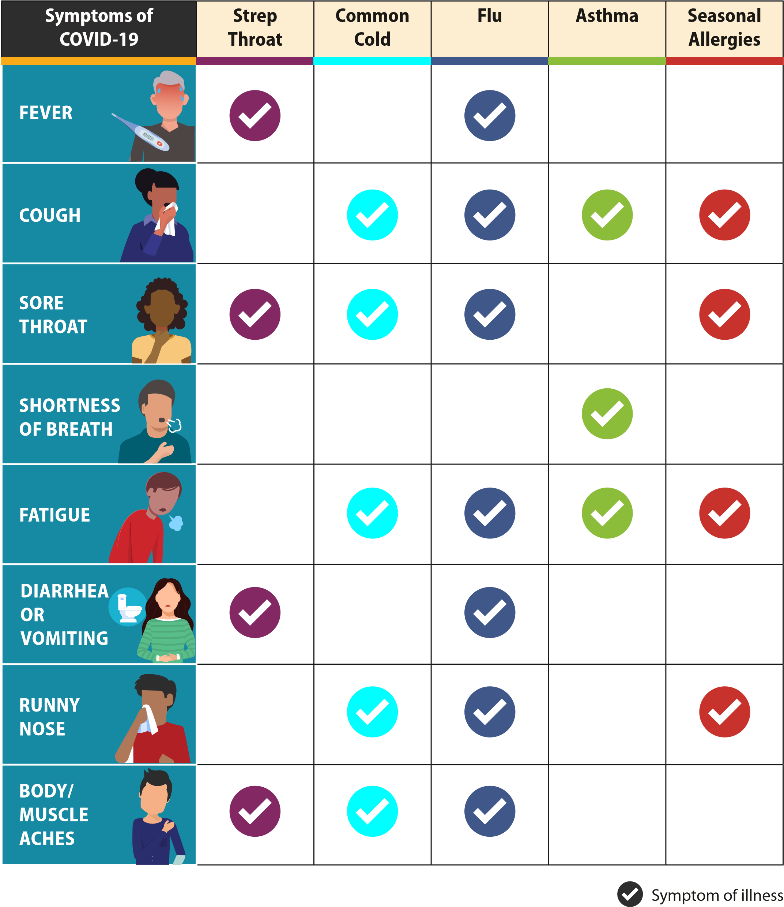
Accommodations:
- Students with diagnosed medical conditions that are related to COVID-19 susceptibility will be provided opportunities for distance learning and other accommodations as appropriate and practicable.
- Faculty/staff with diagnosed medical conditions that are related to COVID-19 susceptibility will be provided accommodations as appropriate and practicable.

Public/Visitors:
- Under the current circumstances, visitors to the building will not be permitted, unless prearranged or in an emergency situation.
- Parents needing to enter the building to drop off or pick up items will only be allowed in the main office. If you are only dropping an item off or picking a student up, you will not have to be screened.
- Parents are encouraged to attempt to schedule an appointment if they are meeting with a teacher or administrator to avoid times when large numbers of children are present. All parents meeting with staff will be screened prior to the meeting.

Personal Protective Equipment (PPE):
In order to minimize exposure to COVID-19, PPE may be needed to limit certain exposures. PPE can include:
- Masks - masks do not take away the need for personal hygiene, social distancing or frequent cleaning efforts.
- Gloves - touching your face with contaminated hands, whether gloved or not, poses a significant risk of infection. Wearing gloves does not diminish the need to wash your hands.

The wearing of masks will not be required, but allowed. Masks will be encouraged for high risk students and staff and those working closely with others. If local, state or federal authorities mandate the wearing of a mask, the district will comply with any such order. Please note social distancing when possible should still be practiced even with the use of gloves and masks.

In addition to using PPE, please remember to:
- Wash your hands often with soap and water for at least 20 seconds. Use hand sanitizer with at least 70% alcohol if soap and water are not available.
- Hand washing properly is the number one defense against any virus.
- Proper removal of gloves reduces the risk of being exposed to contamination.
- Avoid touching your eyes, nose, and mouth.
- Cover your mouth and nose with a tissue when you cough or sneeze or use the inside of your elbow.
- Stay home if you are ill.

Healthy Practices:
- Hand Hygiene and Respiratory Etiquette (CDC Guidance)
  - Teach and reinforce handwashing with soap and water for at least 20 seconds, multiple times throughout the day and increase monitoring to ensure adherence among students and staff.
  - If soap and water are not readily available, hand sanitizer that contains at least 70% alcohol can be used. Hand sanitizer is provided throughout the building.
  - Staff and students are expected to cover coughs and sneezes with a tissue. Used tissues should be thrown in the trash and hands washed immediately with soap and water for at least 20 seconds.

Personal Workspace/Classroom:
Staff will use district approved signage to indicate that a room needs sanitizing or disinfecting. Employees are encouraged to disinfect their own personal workspace throughout the day, giving special attention to commonly touched surfaces.

Shared Workspace:
- Sneeze guards (similar to those found in grocery stores, etc.) will be utilized to allow office personnel to interact with students or visitors while minimizing potential exposure.
- Employees are encouraged to disinfect their own workspace multiple times throughout the day. Alcohol-based sanitizers will be placed throughout work spaces and common areas.
- Cleaning sprays and wipes will be available to staff to clean and disinfect frequently touched objects and surfaces such as keyboards and telephones, when students are not in the room.
- The school custodial staff will clean all workspaces at their designated cleaning times.

Shared Objects:
- Sharing of items that are difficult to clean or disinfect will not be permitted.
- Each child’s belongings will be separated from others’ and in individually labeled containers, cubbies, or areas as much as possible.
- If adequate supplies cannot be acquired to minimize sharing of high touch materials to the extent possible (e.g., assigning each student their own art supplies, equipment), use will be limited to supplies and equipment by one group of children at a time, cleaning and disinfecting supplies/equipment between use will be required.
- The computer lab will be utilized on a minimal basis. Students will utilize their Chromebooks.
- Sharing of student supplies (art, other) will be minimized and/or eliminated.
- Equipment used by more than one student will be sanitized between uses if possible.

Facilities/Custodial/Maintenance Protocols
- All frequently touched surfaces will be disinfected multiple times during the day. These may include door handles, light switches, and any equipment that may be used by multiple students.
- Water fountains will be closed for student use until further notice. Students are encouraged to bring bottled water to school or use the water bottle fillers on water fountains. Please discuss the importance of not sharing water at school.
- Restrooms will be disinfected multiple times during the day.
- Our custodians will ensure there is always adequate soap and paper products available in the restrooms and classrooms with handwashing stations.
- Hand sanitizer will be available in all classrooms and high traffic areas.
- Signs will be posted in the classrooms and restrooms with directions on how to effectively wash hands.
- Deep cleaning is triggered when an employee or student is identified as positive for COVID-19 based on testing.

Disinfectant stations will be placed throughout the building. These will include the cafeteria, entrances, office entrances, gym/physical education classes, etc.

The safety of employees and students is our first priority. Upon reopening, the buildings will be completely deep cleaned and disinfected and we will continue to adhere to all necessary safety precautions. In addition to the deep clean of the office and school before employees and students return, the cleaning steps outlined below are to be taken to protect and to reduce the spread of the infection. Employees should maintain this safety standard by continuously cleaning and disinfection based on the frequency stated in the following table.

GENERAL DISINFECTION MEASURES

Category | Area | Frequency
Workspaces | Classrooms, Offices | At the end of each day and as much as possible throughout day
Appliances | Refrigerators, Microwaves, Coffee Machines | At the end of each use  End of each day
Electronic Equipment | Copier machines, Shared computer monitors, TV’s, Telephones, keyboards | At the end of each use/day and between use
General Used Objects | Handles, light switches, sinks, restrooms | At least 4 times a day
Buses | Bus seats, handles/railing, seat belts, window controls | At the end of each use
Common Areas | Cafeteria, Library, Conference rooms, Gyms, Common Areas | At the end of each use/day; between groups

Preventative Supply Inventory:
- The district has an adequate supply of soap, disinfection, hand sanitizer, paper towels, and tissues. These items will be supplied to staff as needed.
- Medical staff with potential to encounter COVID-19 positive students or staff will be provided with N-95 masks to use when in close proximity with students or staff members.

Classroom Protocols:
The district will take all actions necessary to provide staff and students with as normal a school day as possible during this global pandemic. With this in mind, the district will be implementing the following procedures to maximize the safety of all students. Please keep in mind that our intent for all students is to keep them in a stable group as much as possible while at school.
- All classrooms will be set up to encourage social distancing while balancing the needs for social interaction with other students and the teacher.
- Students will be encouraged to use hand sanitizer before and after moving from one location to another.
- There will be time built into the daily schedule for routine hand washing by both students and teachers.
- Computers and keyboards will be sanitized and wiped down between classes if they are shared.
- Every effort will be made to eliminate the sharing of school supplies, unless the supplies have been disinfected after each use.
- Restroom breaks will be scheduled throughout the day to avoid overcrowding, to the extent possible
- Music and choir classes will be arranged to allow for maximum social distancing. Instruments that are shared will be wiped down between each use. At no time will mouth pieces be shared.

Food Service/Cafeteria Protocols:
The district is taking extra precautions at this time to keep students safe. When school begins several changes are being made in all facilities.
- Some meals may be served in classrooms to reduce the number of students in the cafeterias. This will be on a rotational basis.
- Lunch shifts will be staggered to maximize social distancing as much as possible.
- All students will eat meals with their class or cohort group.
- Students will wash hands prior to eating and prior to engaging in other activities after eating.
- Food will not be shared and unopened food/drinks previously served will not be re-served.
- Use individual packets of condiments.
- All tables will be cleaned thoroughly between uses.
- Food allergies will be taken into account as needed.

Recess Protocols:
We understand the importance of recess time for students and have no intentions of taking recess away. We will continually evaluate our recess protocols and update as needed.
- Classrooms will visit the playground on a schedule that limits interaction between different grade levels.
- Recess times will be spread out throughout the day.
- Students will wash their hands immediately upon re-entering the building

Athletic/Extracurricular Event Protocols:
Student activities and athletics will be conducted as usual to the extent they are permissible under local, state, and federal guidance.
- All sporting events will be subject to MSHSAA guidelines which may supersede our protocols. If these change we will ensure to communicate to all stakeholders in a timely manner.
- Keep in mind that spectator capacity may be reduced to achieve proper social distancing if required. We encourage all spectators to practice social distancing and only sit in family groups.
- Should it become necessary to reduce seating, athletes will be given tickets to give to their guests. All admission fees will still apply and be paid upon entry of event.
- Only administration, gate workers, supervisors, clock, announcers and chain crew will be admitted without a ticket should tickets be required.
- Concession stands will be open but will be subject to regulations in place by the local or state health departments.
- Water bottles will need to be used by all athletes during practices.

Diagnostic and Vaccination Protocols:
- Per CDC guidelines, staff or students who have been fully vaccinated for at least two weeks will not be required to quarantine if they are a close contact.
- The District will continue to work with our local healthcare providers in order to accommodate drive-in vaccination clinics for staff, students and community members.
- The District will continue to work with our local healthcare providers to provide COVID-19 testing as needed. Testing will be done at the healthcare provider’s facility.

Accommodations for Students with Disabilities:
In order to assure that Potosi R-3 School District is making the appropriate accommodations for children with disabilities with respect to the health and safety policies, we meet as a team annually and sometimes more often to develop an IEP that is aligned to the child's needs. The IEP team is formed of parents, regular ed. teachers, special education teachers, administration/LEA, and the school nurse when needed. The students' health needs and medical documentation are documented in the IEP and addressed appropriately within the plan. Accommodations are outlined and followed in the IEP based upon the students' need. All IEP team members are given a copy of the plan to follow.

Continual Review of Safe Return Plan:
The Potosi R-3 School District Administrative Team, along with the SRCSP Committee consisting of members from the community, staff, and students will review this plan quarterly.

Availability of Plan in Other Languages:
The Potosi R-3 School District will provide copies of this plan in other languages upon request. Please contact Mr. Bryce Wilson at (573)438-5485 to make this request. You may also email this request to bwilson@potosir3.org.

Stakeholders Involved in Creating This Plan:
The Potosi R-3 School District would like to thank all of those that took time to attend meetings and contribute to this plan. The District solicited input from local public health officials, school leaders, teacher, school support staff, students and families. Public solicitation was also allowed for during the July 19, 2022 Board meeting in open session meeting when this plan was approved by the Potosi R-3 School District Board of Education. We would like to thank the following for working on this plan:

Alex McCaul, Superintendent
Bryce Wilson, Assistant Superintendent
Rhonda Phares, School Board President
Jeanette Allen, School Board Vice President
Mary Lou Brabham, School Board Secretary
Dallas Thompson, School Board Treasurer
Hunter Belfield, School Board Member
Charles J. Mercille, School Board Member
Andy Kincaid, School Board Member
Shawnee Douglas, Director Washington County Health Department
Dr. Gregory Terpstra, District Medical Advisor
Judy McCaul, Pediatric Nurse Practitioner
Kim Hartley, Director of Special Education
Jason Seiberlich, Director of Technology
Leann Morgan, Director of Food Service
Jennifer Lawson, Director of Transportation Operations
Chris Dicus, Director of Fleet Services
Joni Jacobsen, PAT Director
Patrick Rolland, Director of Maintenance
Steven McCoy, Athletic/Activities Director
Nicole Portell, Principal
Deanna Clapp, Assistant Principal
Jeff Gibson, Principal
Kimberly Bouse, Assistant Principal
Dr. Jodi Elder, Principal
Harry Thurmond, Assistant Principal
Jennifer Woods, Principal
Jill Sansegraw, Assistant Principal
Kathy Christopher, Librarian
Mariah Coleman, Teacher
Regina Moyers, Teacher
Christina Haar, Teacher
Sarah Shaffer, Teacher
Matt Bradley, Teacher
Luci Martin, Teacher
Amanda Politte, Athletic Coach
Cheryl Maxwell, Activity Sponsor
Jordan Simms, Band Director
Kelly Littrell, Parent
Amanda Hedgecorth, Parent
Heather Riddle, Parent
James Huddleston, Grandparent
Kia Gibson, Student Council
Aubree Wilson, Student Council

